SIGN IN

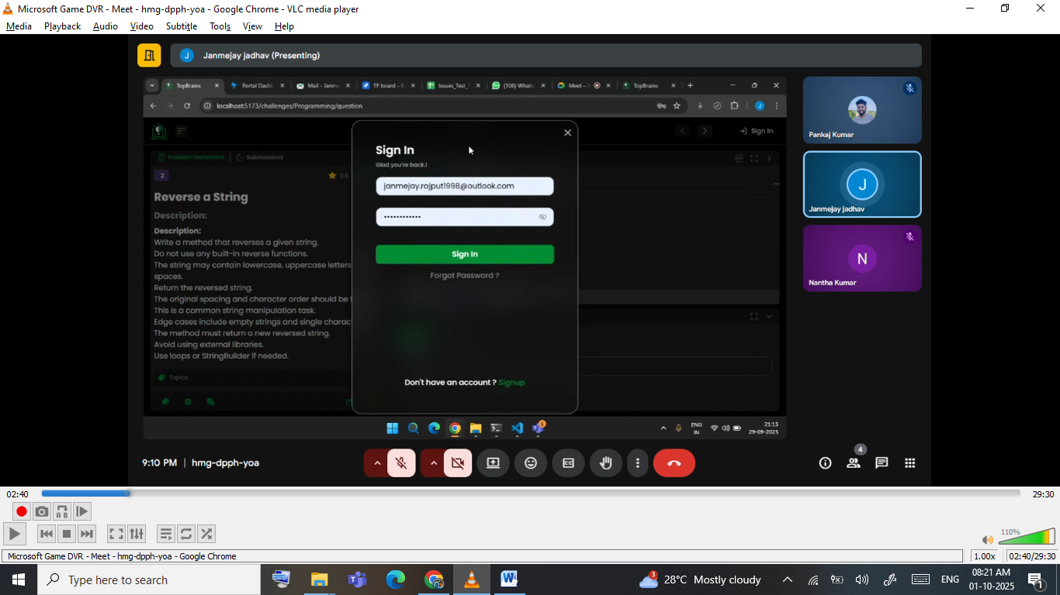
Based on sign in – we have different different roles

Student credential
Student credential-same challenges 2.1
Code can be
Run –multiple times
Submit-once-based on submission-> wrong or right -> user will rewarded with point

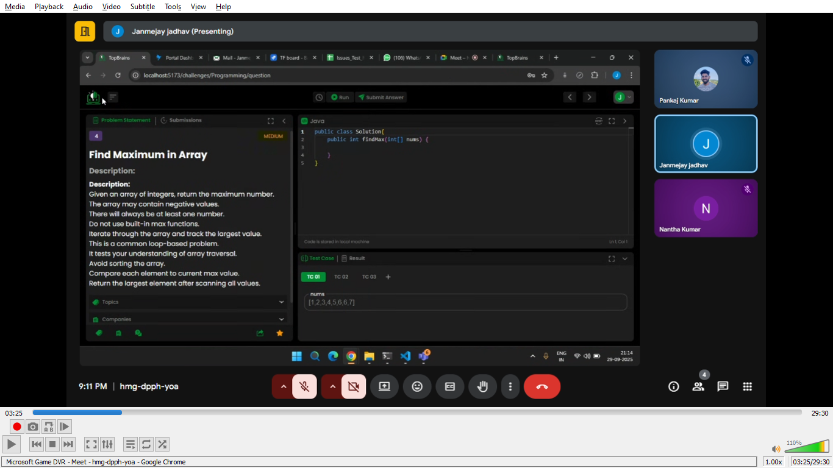
On right corner we have icon to -> navigate inbetween next question and previous question
On left-> icon to get all the list of questions

